**USER GUIDE TO USE NEW INVENTORY LISTING**

1. **Why this tool:**

When operation team is done with their listing work we have to update the new list data, through that data we can check each members performance and can also update weight of the product, if the weight doesn’t match after stock delivered.

This tool is used for daily work updates for operation team.

1. **How it works:**

When we submit the bulk upload ASINS in this tool, it provides with some filed like (index, ASIN, date, restricted, name, weight, comment)

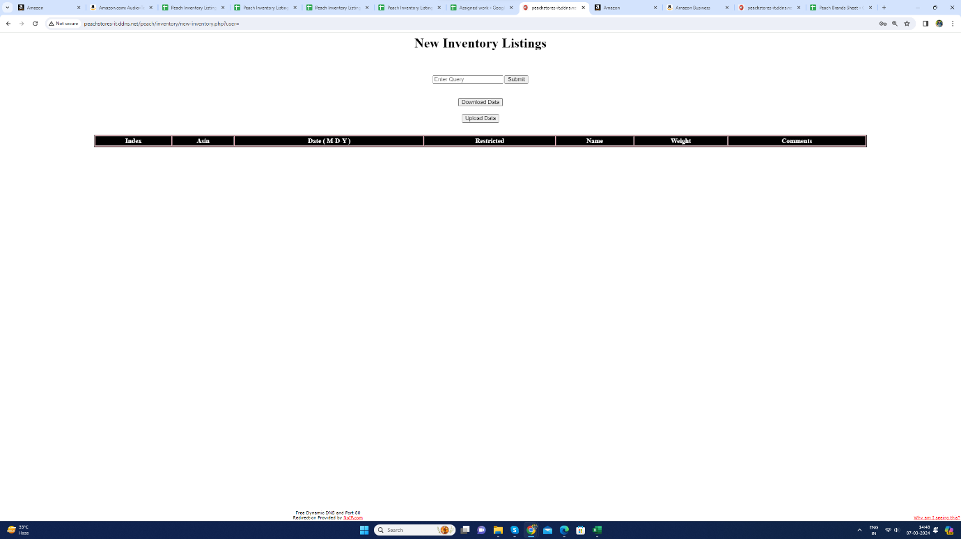

**3. How to use it:**

**Step1:** Upload the bulk upload ASINS in the query field.

**Step 2:** It provides all the details of that ASINS.

**Step3:** Now it shows the result table, there you can see some fields like

Index, ASIN, date, restricted, name, weight, comment), now according to that fields we can check the product index, weight, ASIN, date of upload in the tool and also, we can check the person Name who was uploaded the data.

**Setp4:** And there is one more field called RESTRICTED here the operation team will directly mention “no".

**NOTE:** Here if there is any product got restricted, then operation team will update restricted field to “YES”

**Step 6:** We can also check each product result table data by uploading single ASIN of each product.

**Step 5:** So, Now we can track the each person performance in operation team and also we can do update like (weight changing, updating restricted field).

4. **Any updates required:**